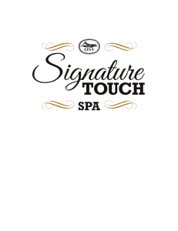
369 Main Street, Sturbridge, MA 01566
Spa: 508-347-5056 x205 Cell: 774-303-9088
SignatureTouch@osv.org www.signaturetouchspa.com
Bridal Party Intake Form

Name: __________________________________________________________________________

Position in Wedding: _____________________________________________________________

Relation to Bride/Groom: ________________________________________________________

Name of Bride & Date of Wedding: _______________________________________________

Email Address: ___________________________________________________________________

Cell Phone: (_______)___________________Date of Birth: _________________________

Street Address: ____________________________________________________________________

Town/City: _______________________________ State: _____________ Zip: ____________

Wedding Services: Hair Makeup Nails/Pedi Skin Care Massage Waxing
Additional:

Wedding Day Desired Style or Look _______________________________________________

Do you have a photo? Yes * No
*You may attach photo to form or email it to us prior to the wedding date

Length/Texture of Hair______________________________ Skin Tone:___________________
To secure your spa reservation a 50% non- refundable deposit on your total services
is required. The deposit can be made by check payable and mailed to :
Signature Touch c/o Missy Winsky 9 Dennis Wilbur Drive Charlton, MA 01507
Or
Credit Card#_______________________________Expiration date:___________
Name on Card:______________________________3 digit code:______________
If you have any questions please feel free to contact me at 774-303-9088 or email me at
SignatureTouch@osv.org and I will be happy to assist you. Thank you. Missy Winsky, owner

Wedding Day reminder:
Please arrive for your services with clean, dry hair with gel and/or styling product. Bring any accessories that you may want to use to complete your look. Remember to wear a button front shirt. Most importantly relax and have fun!!

